- Create a State Chart Diagram for Microwave Oven Operation using StarUML. Attach print out.

STATECHART DIAGRAM:
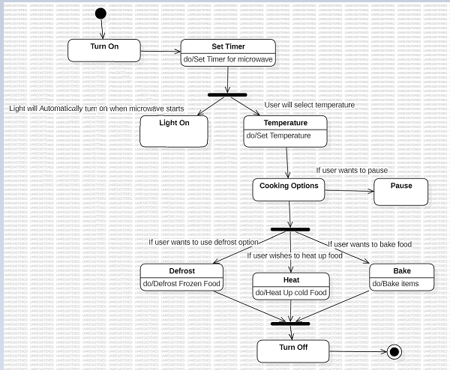

Cooking Options:
  - Pause the operation.
  - Defrost frozen food (do/Defrost Frozen Food).
  - Heat cold food (do/Heat Up Cold Food).
  - Bake items (do/Bake Items).

- Create Sequence and Collaboration diagrams for Online Bookshop where the Web customer actor can search inventory, view and buy books online. Also attach the printout.

SEQUENCE DIAGRAM:
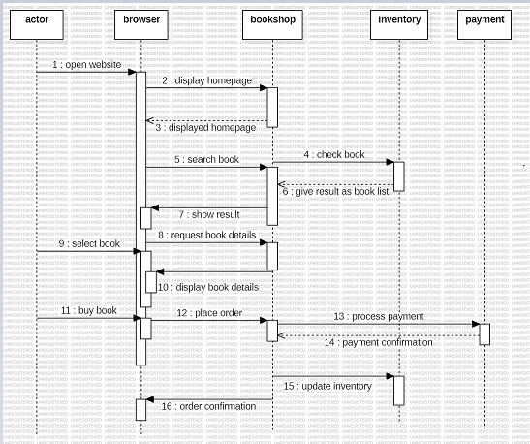

COLLABORATION DIAGRAM:

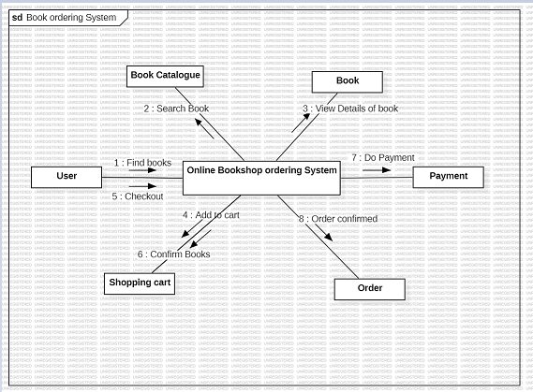

3. UMLdiagrams can also be created by means of variety of different online tools. Visual Paradigm is one of them. Create any three UML diagrams using this online tool for the ‘Online Bookshop System’. Attach print out

USE CASE DIAGRAM:

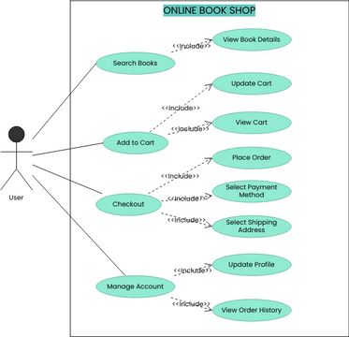

CLASS DIAGRAM:

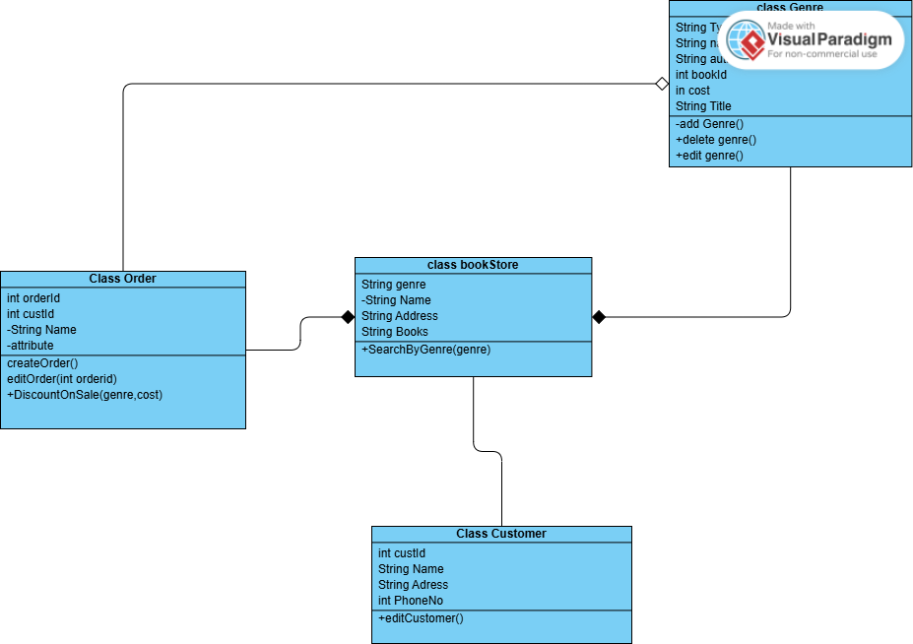

ACTIVITY DIAGRAM:
